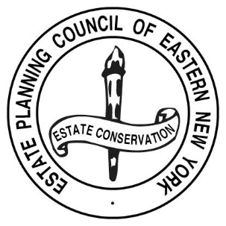
ESTATE PLANNING COUNCIL OF EASTERN NEW YORK, INC.

Register online
or
Pay by check and use this
RESERVATION FORM

Reservation Form must be accompanied by a CHECK PAYABLE TO THE ESTATE PLANNING COUNCIL of EASTERN NY, INC. Please mail check with this card to:
Stephanie Cogan, Executive Director
EPC ENY
PO Box 11136
Loudonville, NY 12211-0565

Please make __________ reservation(s) for the Thursday, May 9, 2019, Estate Planning Council program at Wolferts Roost Country Club, Albany, NY.
$35.00 Member or first-time guest fee, if received by May 2, 2019;
$55.00 per person Non-Member and Members fee, if received after May 2, 2019.

A check in the amount of $_______________ is enclosed.

Name(s) of those attending:
_______________________________________________________________________________________________________
_______________________________________________________________________________________________________
_______________________________________________________________________________________________________
Thank you!

