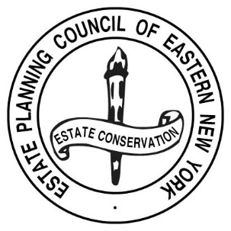
ESTATE PLANNING COUNCIL OF EASTERN NEW YORK, INC.

Register online
or
Pay by check and use this
RESERVATION FORM

Reservation Form must be accompanied by a CHECK PAYABLE TO THE ESTATE PLANNING COUNCIL of EASTERN NY, INC. Please mail check with this card to:
Stephanie Cogan, Executive Director
EPC ENY
PO Box 11136
Loudonville, NY 12211-0565

Please make __________ reservation(s) for the Tuesday, November 28, 2023 Estate Planning Council program at Wolferts Roost Country Club, 120 Van Rensselaer Blvd., Albany, NY 12204.
$50.00 Member or first-time guest fee;
$75.00 per person Non-Member

A check in the amount of $_______________ is enclosed.

Name(s) of those attending:
_______________________________________________________________________________________________________
_______________________________________________________________________________________________________
_______________________________________________________________________________________________________

Thank you!

