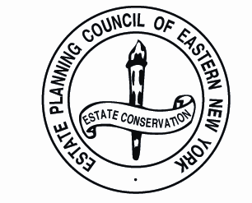

ESTATE PLANNING COUNCIL
EASTERN NEW YORK CHAPTER

Annual Meeting, May 22, 2018
Announcements:
Officers for 2018-2019 Elected by the Board of Directors:
Peter Gregory President
Lucy Kats, Esq. Vice President
Sarah Dorsey, CPA Treasurer
Marilyn Kraus Secretary
Kevin Smith, TO, CFP®, CTFA Immediate Past President

Interim Directors Nominated by the Board of Directors:
To fulfill the remainder of Sarah Dorsey’s term ending June 30, 2019:
Jessica Coombs, Esq
To fulfill the remainder of Marilyn Kraus’ term ending June 30, 2019:
Debra Verni, Esq.
Member Vote:
Directors Nominated by the Board of Directors:
Three-year term from July 1, 2018 to June 30, 2021
Matthew J. Dorsey, Esq.
Michael J. Tommaney, Esq.
Phillip M. Tribble, Esq.

